**UCS540**

**Data Structures and Algorithms**

**KANISHK BEHL**

**102105058**

**3EIC2**

**LAB ASSIGNMENT 1**

|  |  |
| --- | --- |
| **Objective: Students should be able to write programs in ‘C’ language. Simple programming** | |
| **exercise on various progamming constructs in ‘C’ follows.** |  |

1. Write a program in C to convert miles into kilometers (Km). Hint: 1 Mile=1.609 Km. [Use macros, relevant name and types for variables].

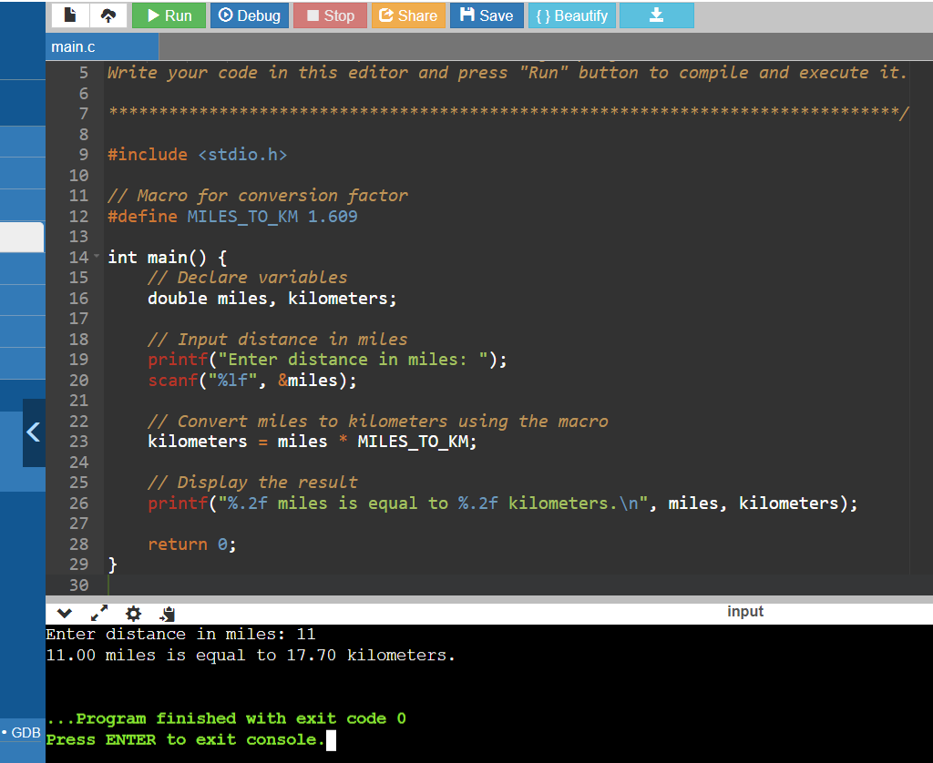

1. Write a program to find the number of positive, negative and zeros in a sequence of inputs (numbers) entered as data.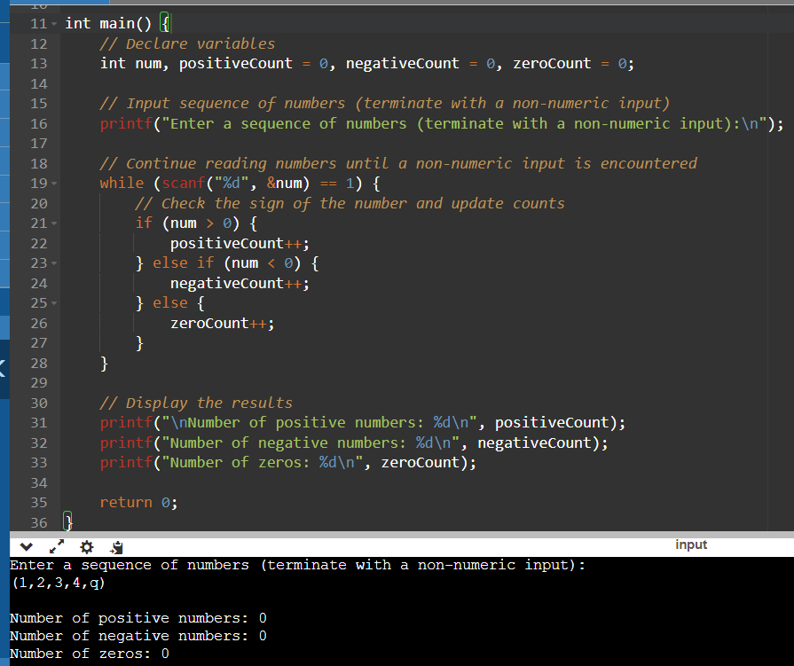
2. Compute the tax due based on a tax table given below:

Program Input: Salary amount.

Program Output: Returns the tax due for 0.0 <= salary <= 150,000.00; returns -1.0 if salary is outside the table range.

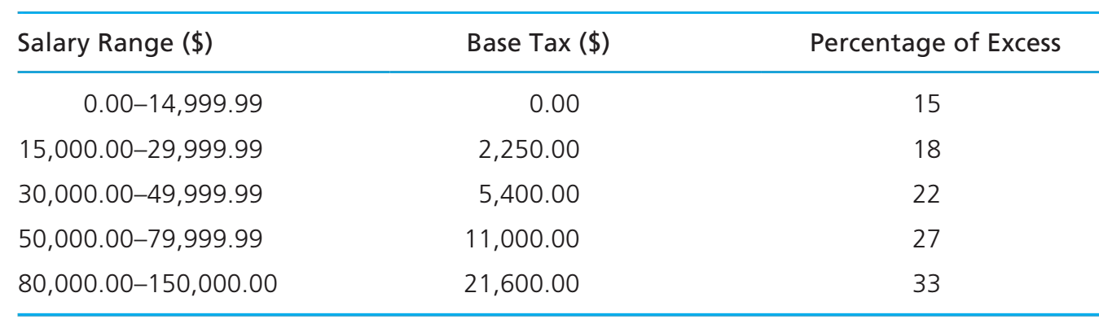

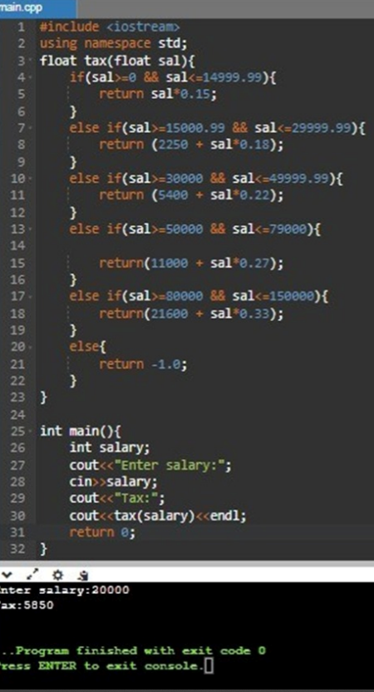

1. Write an interactive program (menu driven) in ‘C’ (using functions) to compute the area of a selected geometrical figure from a list of such figures (square, rectangle, and circle).

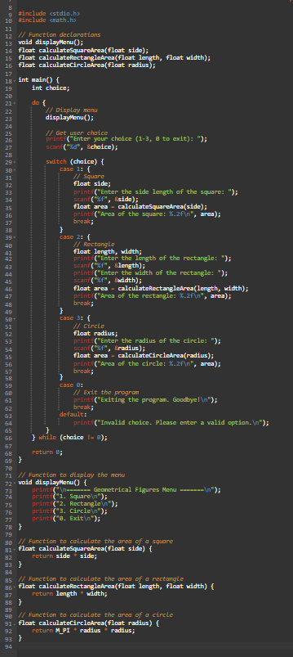

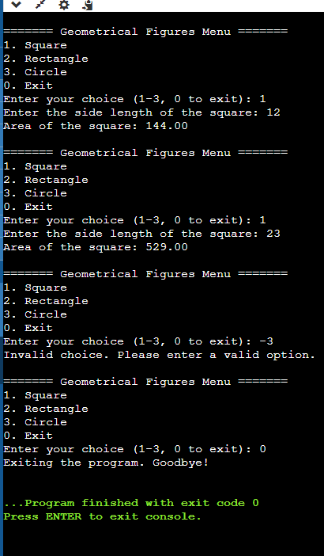

1. Write a program to display first n elements of Fibonacci series.

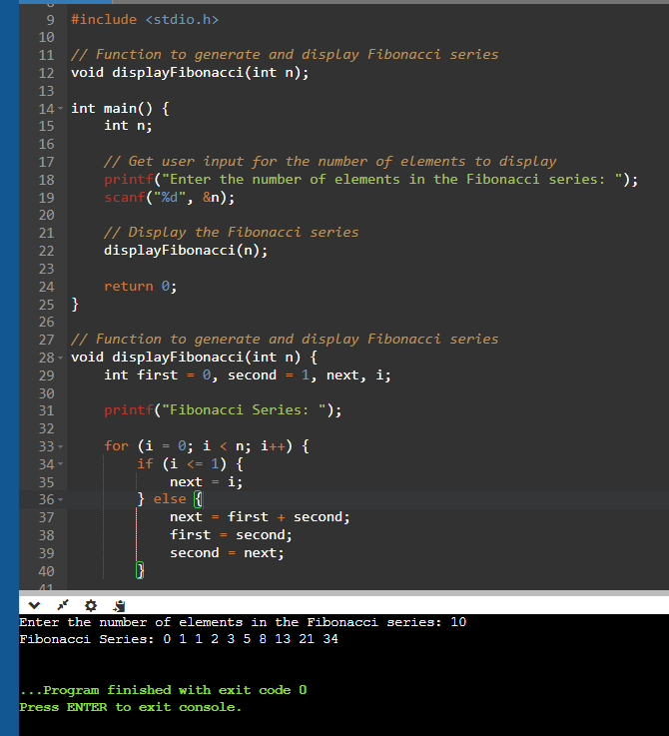

1. Write a program to print a table book from Table X to Table Y. X and Y are user inputs.

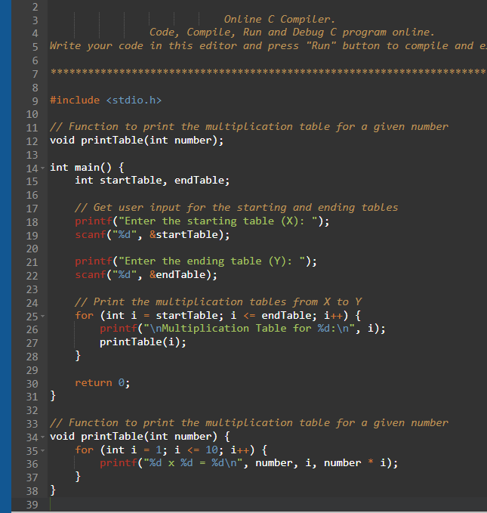

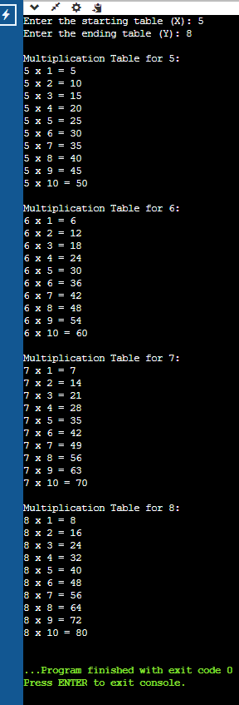

1. Write a program to compute factorial of a number using iterative approach.

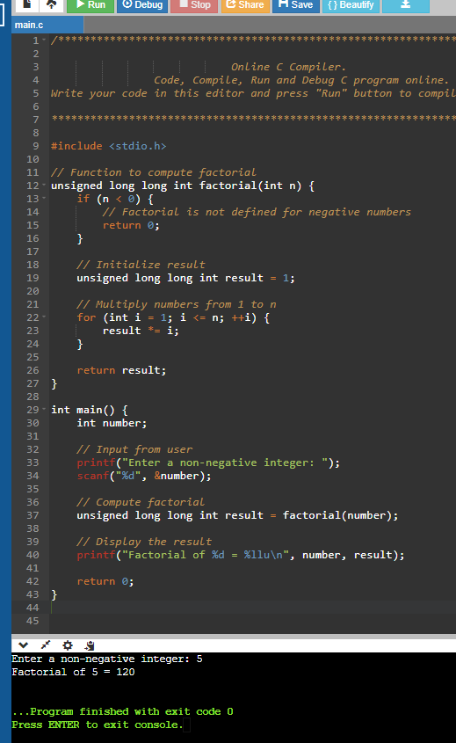

1. Write a program to swap two numbers using functions.

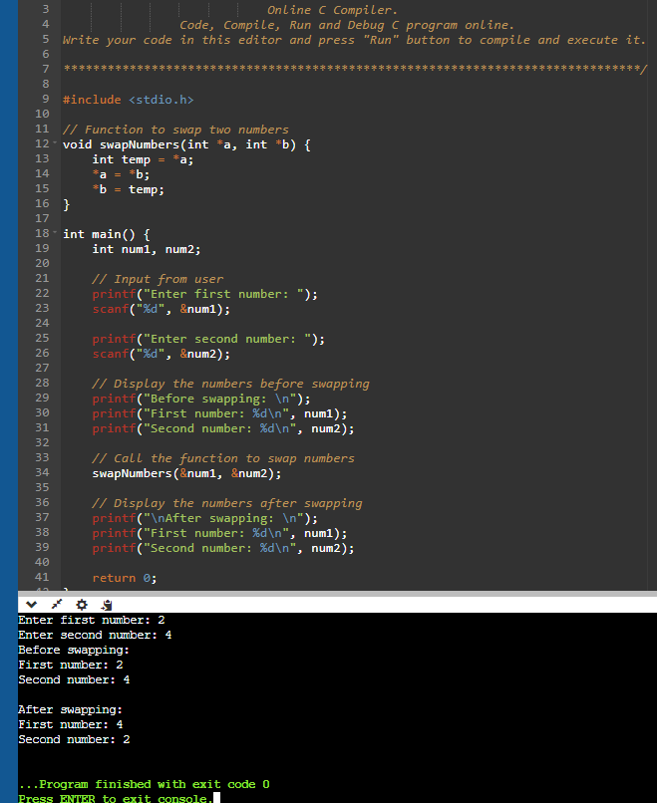

1. Write a function that returns the first integer between n_min and n_max entered as data to the calling function (main).

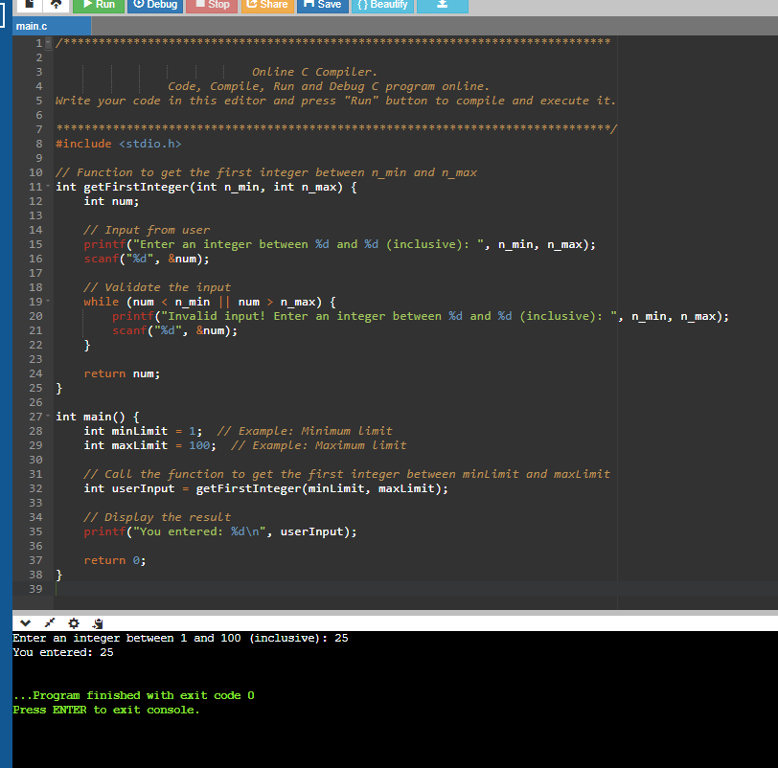

10)Write nests of loops that cause the following output to be displayed.

